**Documents required for enrollment process:**

1. JPG format photograph (below 200 kb)
2. Scanned copy of 8th sem mark sheet or provisional certificate in PDF format. ( any other semester mark sheet not accepted).
3. Aadhar card scanned copy.
4. Capgemini Salary Account details (Bank a/c no. and IFC code for updating in portal).

**ENROLLMENT PROCESS - APPRENTICE BOARD (WESTERN REGION).**

1. Please Visit [**https://portal.mhrdnats.gov.in/**](https://portal.mhrdnats.gov.in/) for enrollment
2. Click on “Register” tab.
3. Select Category as “Student” & click on “Register” tab.
4. Select Enrollment type as “Graduate” & fill relevant mandatory details required for enrollment.

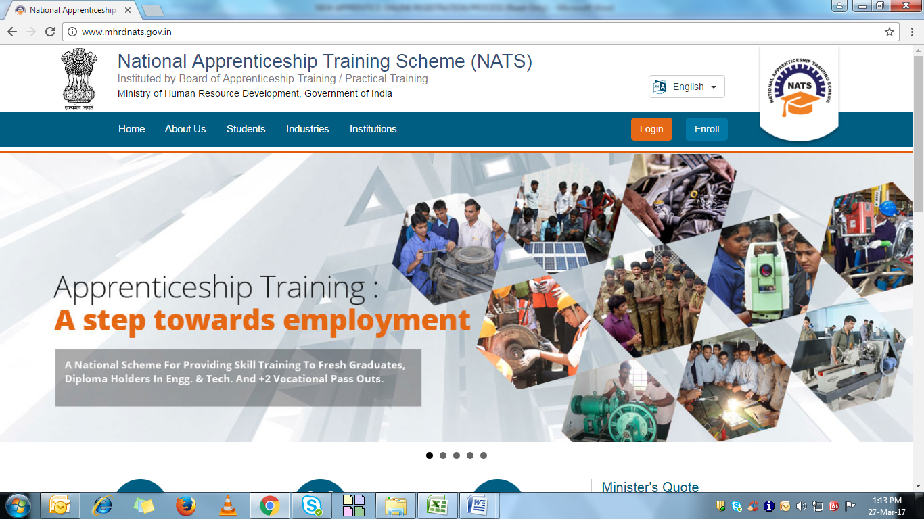

Please fill your details as per the guidelines mentioned in below screenshot.

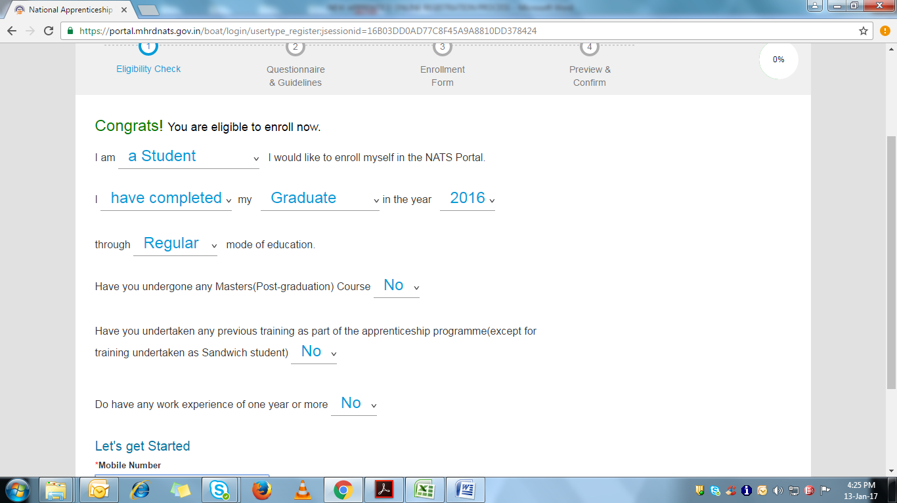

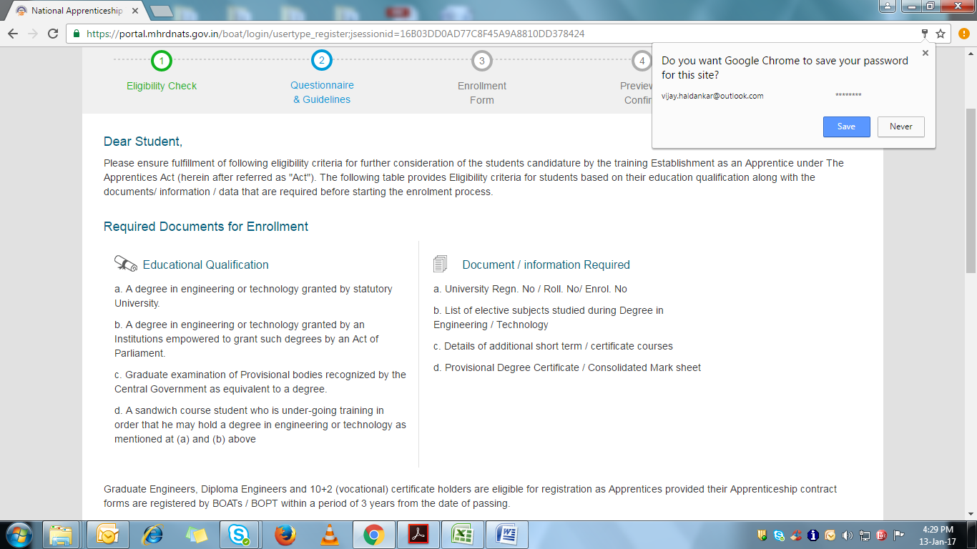

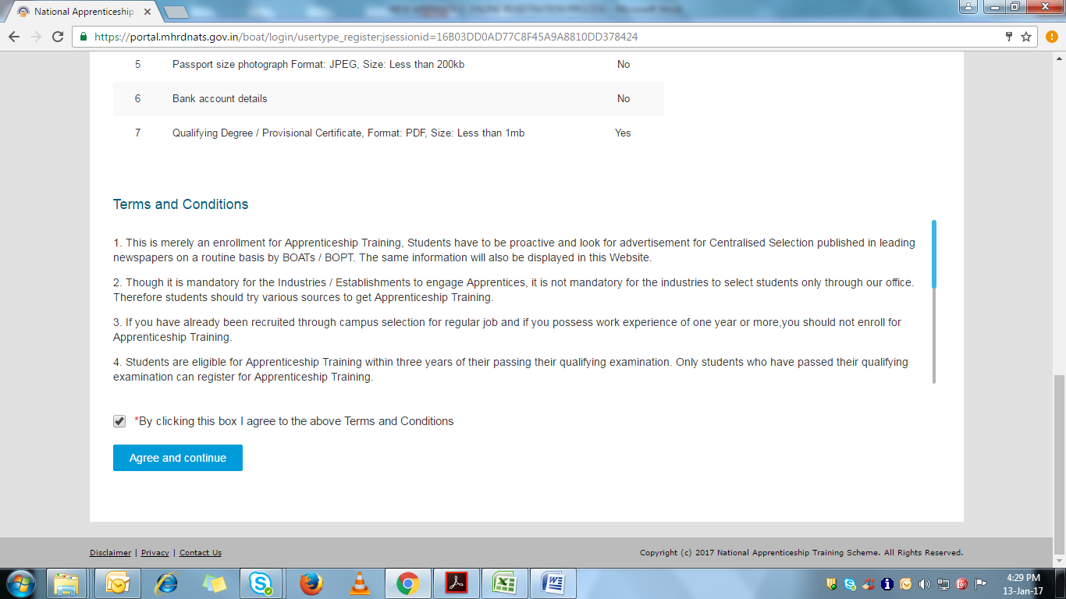

Fill in your relevant personal address details. Below screen shot is for your reference.

Do not copy details.

Upload you photo as well as your government documents as per the requirements.

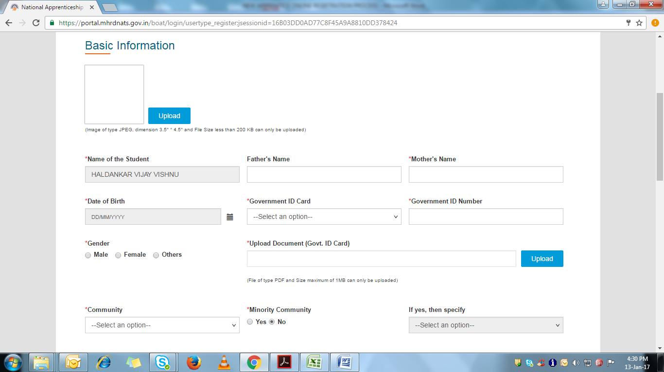

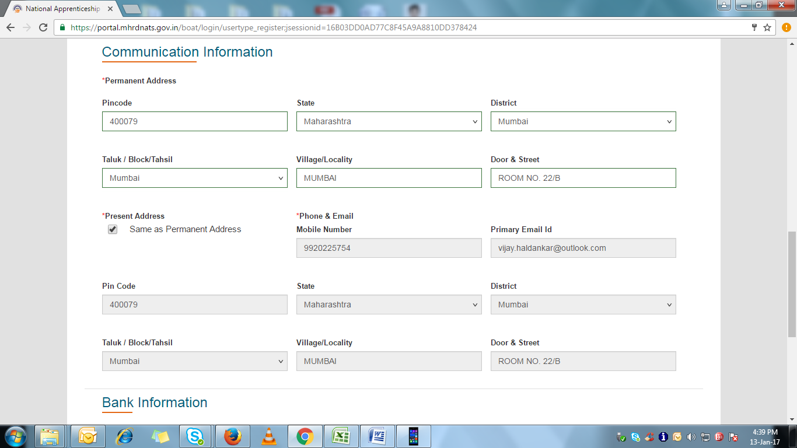

**Please filled only your CG Salary a/c Details in Bank Information Section:**

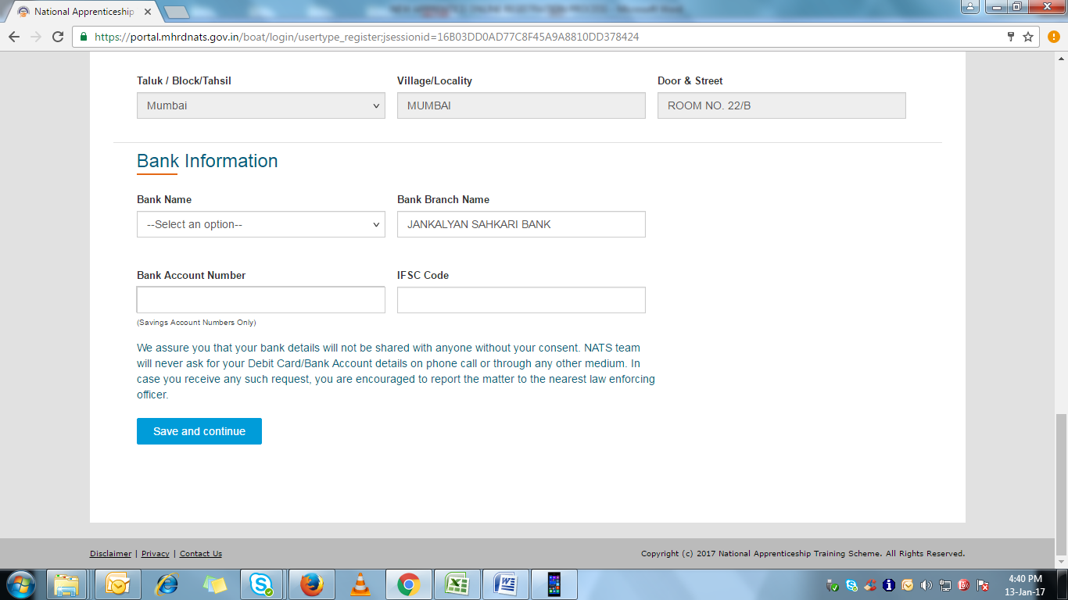

**Please fill your Educational Details in below Section:**

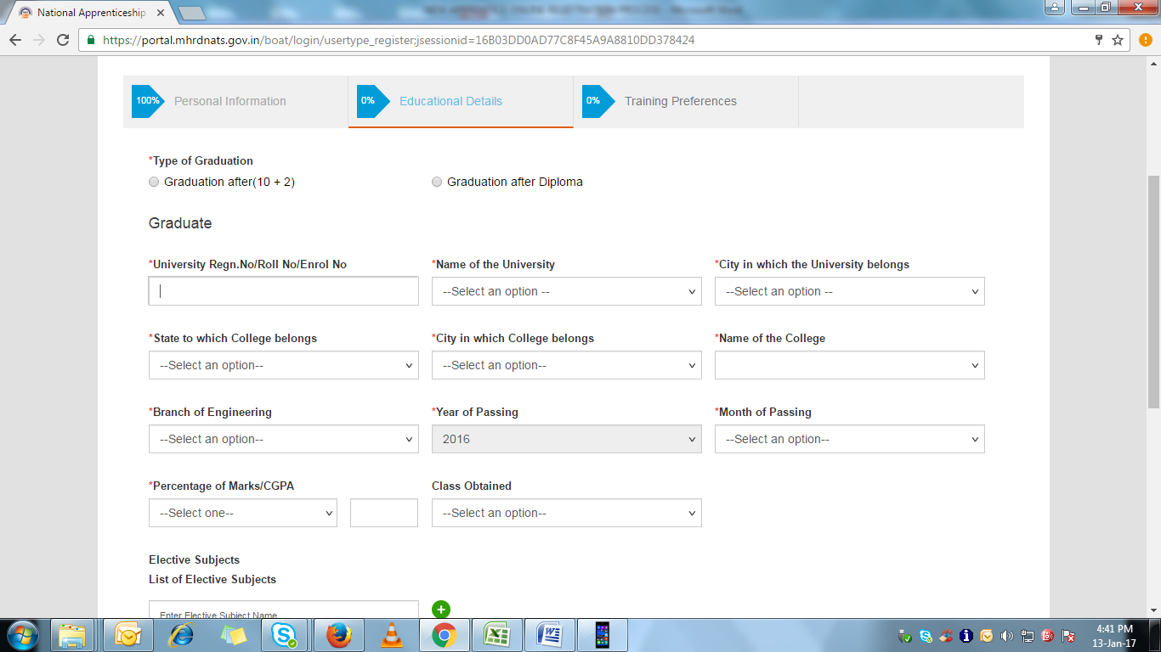

**Please upload your 8th semester Mark sheet with details asking for:**

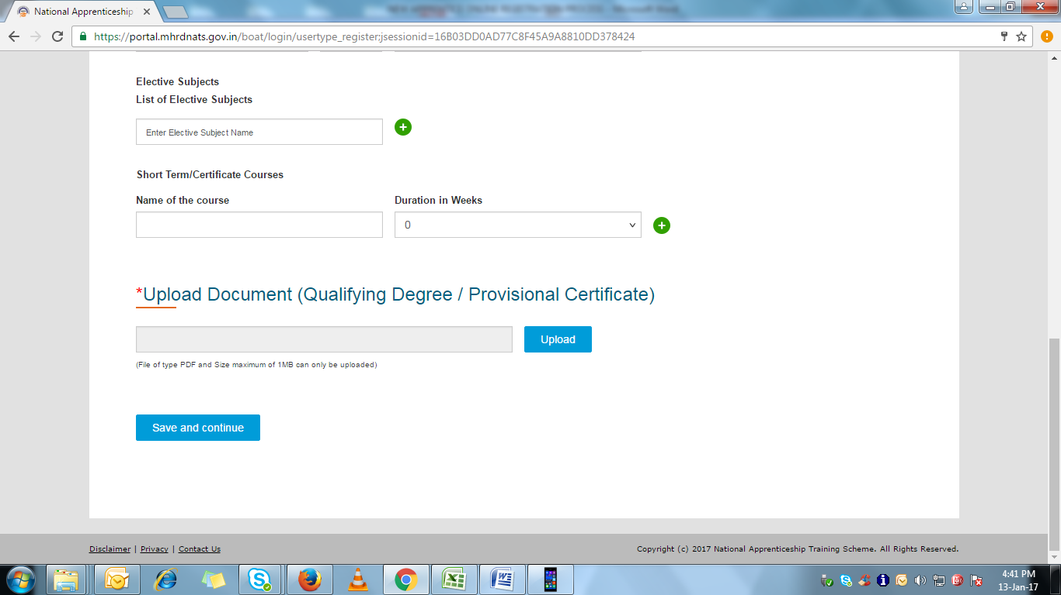

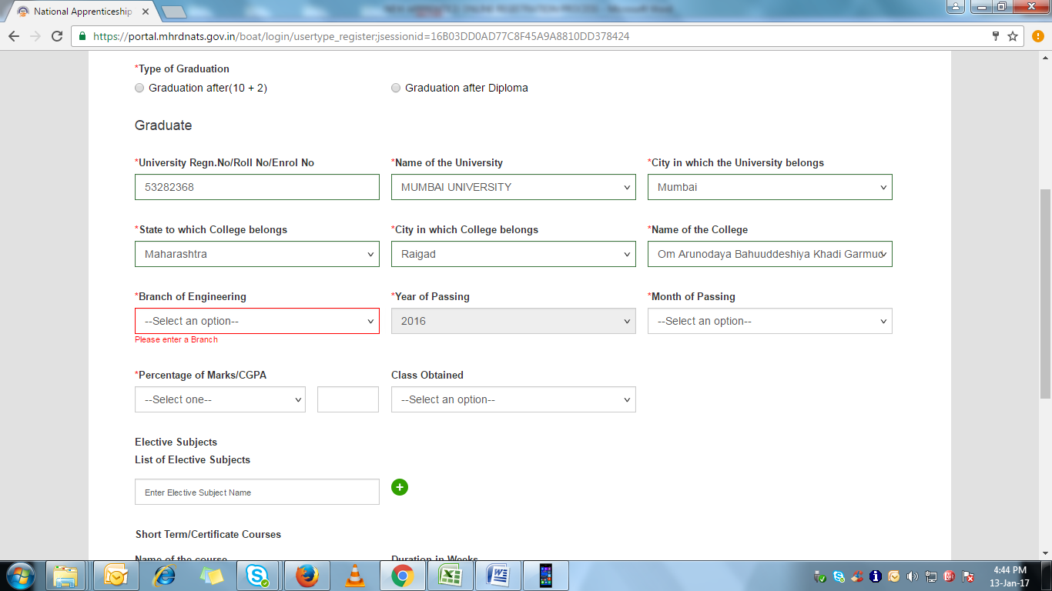

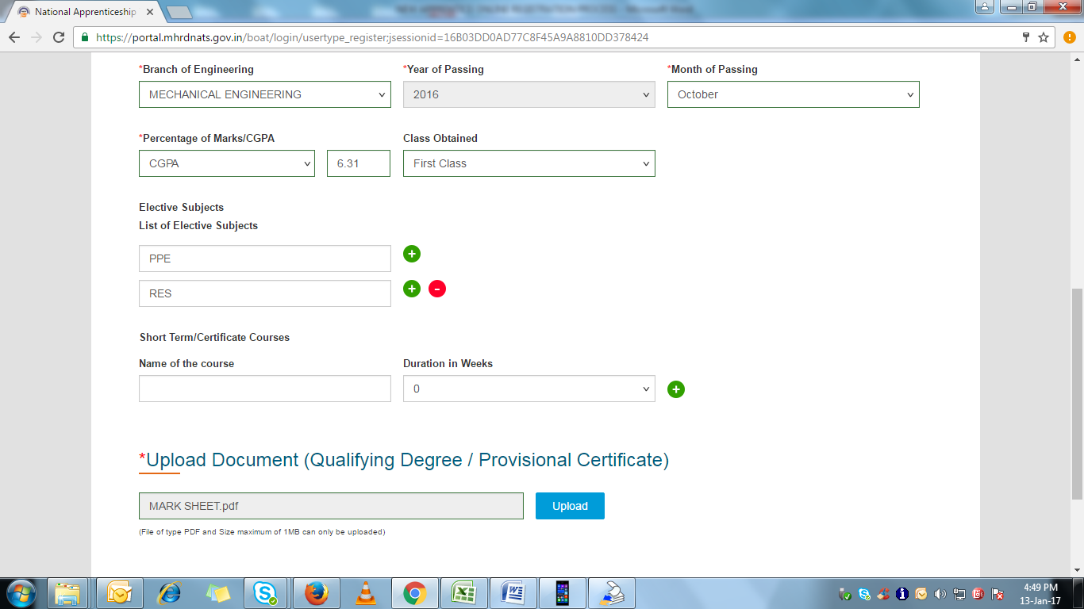

**Post submission you will be enrolled successfully as Apprentice & get user id & password.** **Please share the enrollment no. (user id) with your Employee ID to us on** [**apprentice.in@capgemini.com**](mailto:apprentice.in@capgemini.com) **for further process & keep the details with you to login in to the portal & get your Apprentice Certificate online.**

Further kindly make note of below:

1. Enrollment process is carried on for compliance under Apprentice Act, 1961.
2. You will be treated as “On-job” trainee & will get benefits as per Company policies.
3. Post completion of one year of service, Apprentice team will connect with for requirement of “Progress Report – App 6 form” which is part of compliance process.
4. Enrollment process & details needs to be sent to mentioned email id within 10 days from your DOJ.
5. You can email your details from your personal email id.
6. Do not forget to quote your CG employee id in email.
7. Apprentice team will connect separately for ‘Apprentice Contract Registration’ process.
8. In case any query, please drop email to [apprentice.in@capgemini.com](mailto:apprentice.in@capgemini.com)

**Important Notes:**

1. While filling online form do select back option, that effect you will log out from portal & need to do whole process again.
2. If any wrong information updated by you in previous page, complete your rest information on portal & submit your form. After that re-login with your user id & password provide by the Apprentice Boat & do the changes.
3. Keep your user id & password with you, after completing your apprentice training Apprentice Boat will generate the certificate on same user id.